PANDAS IN PYTHON
Introduction to Pandas
Pandas is an open-source Python library used for data manipulation, analysis and cleaning. It provides fast and flexible tools to work with tabular data, similar to spreadsheets or SQL tables.
Pandas is used in data science, machine learning, finance, analytics and automation because it integrates smoothly with other libraries. With Pandas, you can load data, clean it, transform it, analyse it, visualize it all in just a few lines of code.
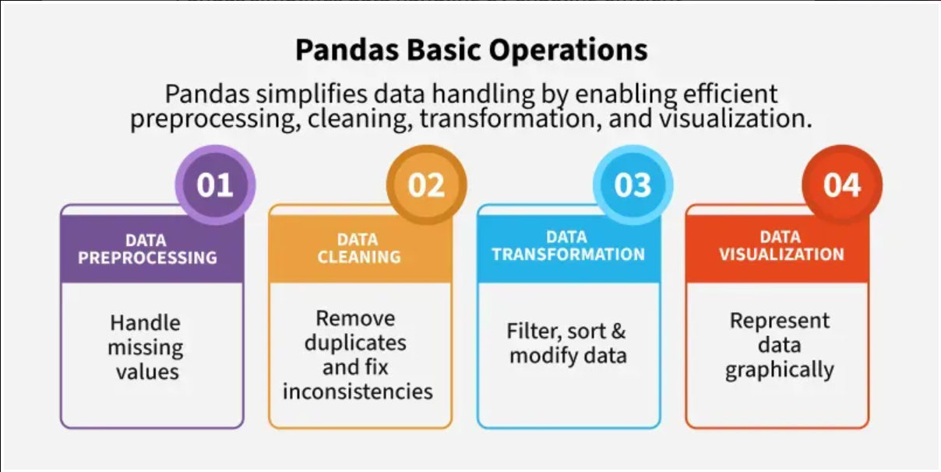
Why Pandas?
- Data Science Essential: Pandas is a cornerstone for data analysis and machine learning workflows.
- Ease of Use: It simplifies complex operations like filtering, grouping, and aggregating data.
- Versatility: Works with multiple data formats (CSV, Excel, SQL, JSON, etc.).
- Integration: Compatible with visualization libraries like Matplotlib and Seaborn.

Key Features
- DataFrame and Series: Efficient structures for handling large datasets.
- File I/O: Read and write data from CSV, Excel, SQL, JSON.
- Missing Data Handling: Built-in methods like dropna() and fillna().
- Label-based Indexing: Use loc and iloc for intuitive data selection.
- GroupBy Operations: Aggregate and transform data easily.
- Reshaping: Pivot tables, stack/unstack operations.
- Visualization Support: Quick plotting with .plot().

Data Cleaning, Aggregation, and Visualization
Data Cleaning
- Remove duplicates.
- Handle missing values.
- Convert data types.
Aggregation
- Group data by categories.
- Apply functions like sum(), mean(), count().
Visualization
- Quick plots using .plot().
- Integration with Matplotlib and Seaborn.

Data Structures in Pandas
Pandas provides two data structures for manipulating data which are as follows:
1. Pandas Series
A Pandas Series is one-dimensional labelled array capable of holding data of any type (integer, string, float, Python objects etc.). The axis labels are collectively called indexes. Series is created by loading the datasets from existing storage which can be a SQL database, a CSV file or an Excel file.
2. Pandas Data Frame
Pandas DataFrame is a two-dimensional data structure with labelled axes (rows and columns). It is created by loading the datasets from existing storage which can be a SQL database, a CSV file or an Excel file. It can be created from lists, dictionaries, a list of dictionaries etc.

Operations in Pandas
Pandas provides essential operations for working with structured data efficiently. The sections below introduce the most commonly used functionalities with short explanations and simple examples.
1. Loading Data: This operation reads data from files such as CSV, Excel or JSON into a DataFrame.
2. Viewing and Exploring Data: After loading data, it is important to understand its structure and content. These methods allow you to inspect rows, summary statistics and metadata.
3. Handling Missing Data: Datasets often contain empty or missing values. Pandas provides functions to detect, remove or replace these values.
4. Selecting and Filtering Data: This operation retrieves specific columns, rows or records that match a condition. It allows precise extraction of required information.
5. Adding and Removing Columns: You can create new columns based on existing ones or delete unwanted columns from the DataFrame.
6. Grouping Data (GroupBy): Grouping allows you to organize data into categories and compute values for each group for example, sums, counts or averages.

